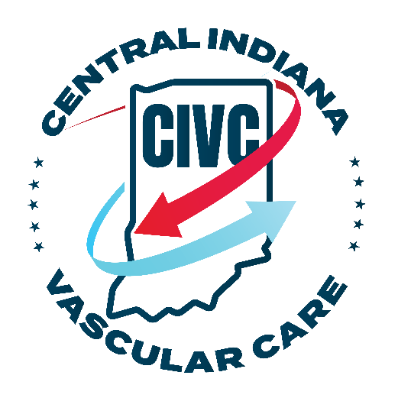
Patient Welcome Letter
We would like to take this opportunity to thank you for selecting Central Indiana Vascular Care to provide you with quality patient care. As a team, we are committed to our patients and your overall satisfaction from your initial visit through your treatment plan.
It is our responsibility to assure that your experience in our Center will be rated not merely satisfied, but exceptional.
If at any time during your visit there is anything we can do to improve your experience or better respond to your needs, please do not hesitate to call upon any member of our staff for assistance.
Again, thank you for providing us the opportunity to meet your care needs.
Sincerely,
The CIVC Team

Intake Form
Patient Name: _____________________________________________________
Date of Birth: ____________________________
Referring Facility: ______________________________
Referral form Completed by: ________________________________
 |  |  |  |  |  | DEMOGRAPHICS INFORMATION
Gender |  |  |  |  |  |  |  |  |  | SSN#
Address |  |  |  |  |  |  |  |  |  | MR#
City
State/Zip
Cell No
Phone No
 |  |  |  |  |  | INSURANCE INFORMATION
Payor Name |  |  | Payor Number |  | Category |  | Factor |  | Group Number |  |  | Subscriber Name |  | Relationship
 |  |  |  |  |  | EMERGENCY CONTACTS
Name: |  |  |  | Relationship to patient: |  |  |  | Home Phone No. |  |  |  |  | Work Phone No.
The above information is true to the best of my knowledge. I authorize my insurance benefits be paid directly to the physician. I understand that I am financially responsible for any balance. I also authorize Central Indiana Vascular Care, LLC or to release any information required to process my claims.
Patient / Guardian Signature Date

Patient Assignment of Benefits

PATIENT NAME

SOCIAL SECURITY NUMBER

DATE
I hereby assign to Central Indiana Vascular Care, LLC payment of all authorized Medicare Medicaid or other insurance benefits for any and all services furnished to me by Central Indiana Vascular Care, LLC and direct that such benefits be paid directly to Central Indiana Vascular Care, LLC and not to me. If these benefits are sent to me in error, I recognize that these benefits are owed to the practice listed above and I will immediately forward the benefit payment.
I, hereby, authorize Central Indiana Vascular Care, LLC to use my information for a range of purposes including: insurance/payment eligibility verification; billing and collecting money due from, private and public payors or their agents including insurance companies, managed care entities, my employer, state and federal government programs and the Bureau of Workers' Compensation; obtaining pre-admission or continued care certification; quality of care assessment and improvement activities, evaluation of the performance or qualifications of physicians and health care workers; conducting healthcare staff training and education programs, ensuring compliance with legal, regulatory and accreditation requirements, and public health activities. I authorize Central Indiana Vascular Care, LLC to utilize or release my health information, whether written, verbal, electronic, or by facsimile to such employees, agents or third parties as are necessary for these purposes and to companies who provide billing services for physicians involved in my medical care.

Patient Signature | Date

Patient / Guardian Signature Date

PLEASE NOTE: If the patient is physically or mentally unable to sign, a representative may sign on the patient's behalf. In this event, the statement's signature line must indicate the patient's name followed by the representative's name, address, relationship to the patient, and the reason the patient cannot sign. The authorization is effective indefinitely unless patient or patient's representative revokes this arrangement.

POLICY REGARDING PATIENT FINANCIAL RESPONSIBILITY

Providing quality medical care to our patients is our primary concern. The following is a summary of our financial policy. We would be happy to provide further clarification if necessary. We ask that you read and sign the following to acknowledge that you have been advised of your financial responsibility for medical services provided here at Central Indiana Vascular Care, LLC.
We have contracts with many insurance companies, and we will bill them as a service to you. We will let you know if your plan is one for which we are a designated provider. If you wish to be seen at Central Indiana Vascular Care, LLC, you are responsible for payment of all co-pays and/or deductible charges at the time of service. If your insurance is a plan for which we are not a designated provider, we are more than willing to provide care and you will be responsible for payment at the time of service. As the responsible party, you are responsible if your insurance company declines to pay for any reason.
The person signing on behalf of the Patient as the Responsible Party must:
- Inform Central Indiana Vascular Care, LLC of the current address.
- And phone number for the patient and the responsible party.
- Present all current insurance cards prior to each office visit.
- Verify at each visit that the information is current by signing our data sheet.
- Pay any required co-pay at the time of the visit.
- Pay any additional amount owing within 30 days of receiving a statement from our office. (When Central Indiana Vascular Care, LLC receives an explanation of benefits (EOB) from your insurance company, any amounts that you need to pay will be billed to you.)

We accept payment in the form of credit card, cash or check. Any checks returned to us due to insufficient funds; or any other reason, will result in a fee of $25.00 each.
I have read this financial policy and understand that I have financial responsibility for payment of medical services provided by Central Indiana Vascular Care, LLC, and hereby assume and guarantee payment of all expenses incurred during my office visit. Should legal action be required to secure payment of this account, I agree to pay the legal expenses incurred by this office.

Signature of Patient / Responsible Party Date

Patient Consent for the use and Disclosure of Protected Health Information

With my consent, Central Indiana Vascular Care, LLC may use and disclose protected health information (PHI) about me to carry out treatment, payment, and health care operations (TPO). Please refer to Central Indiana Vascular Care, LLC Notice of Privacy Practices for a more complete description of such uses and disclosures. I have the right to review the Notice of Privacy Practices prior to signing this consent.
I understand that Central Indiana Vascular Care, LLC reserves the right to revise its Notice of Privacy Practices in accordance with Section 164.520 of the Code of Federal Regulations. A revised Notice of Privacy Practices may be obtained by forwarding a written request to Privacy Officer, Central Indiana Vascular Care, LLC, 853 N. Emerson Ave Suite F, Greenwood, IN 46143.
As a patient, you have a right to inspect copy, amend, request a restriction, or revoke a prior restriction on the use and disclosure of your Protected Health Information (PHI). You may also request a copy of an accounting of disclosures, which will detail all disclosures made for reasons other than treatment, payment, or health care operational purposes. Central Indiana Vascular Care, LLC is not required to agree to the restrictions that I may request. However, if Central Indiana Vascular Care, LLC agrees to a restriction that I request, the restriction is binding on the Central Indiana Vascular Care, LLC.
I have the right to revoke this consent, in writing at any time, except to the extent that Central Indiana Vascular Care, LLC has taken action in reliance on this consent.
By signing this form, I am consenting to Central Indiana Vascular Care, LLC use and disclosure of my PHI to carry out TPO. I am also acknowledging that I have been presented with the Central Indiana Vascular Care, LLC Notice of Privacy Practices.
If I do not sign this consent, Central Indiana Vascular Care, LLC may decline to provide treatment to me.

Signature of Patient, Legal Guardian, or Representative | Date

Patient's Name (Please Print)

Authorization for Release of Medical Records

Name: ________________________________________________________ Date of Birth: _____________
Social Security Number: __________________________________
Address: ________________________________________________________________________________
City: __________________________ State: __________________ Zip: ______________________________
Phone: ______________________________________________________

RELEASE MY MEDICAL RECORDS TO:
Central Indiana Vascular Care, LLC
853 N. Emerson Ave. Suite F
Greenwood, Indiana 46143
Phone 317-868-7979
Fax 317-743-4070

FROM: Central Indiana Vascular Care, LLC

Please release a copy of:
PATIENT INFORMATION (Please Print):
BY MY SIGNATURE, I AUTHORIZE RELEASE OF MEDICAL RECORDS
Patient:
Date: ___________________________

DNR POLICY

It is the policy of Central Indiana Vascular Care, LLC to always perform CPR when indicated. If you have a DNR order in place and it is your wish to have your DNR order honored, you will need to have procedure scheduled at another facility.

